Joseph Silva Jr.

03/21/21

CS 340 – Assignment: 2

SNHU

**Commands**

**I: Importing and Indexing a Data Set**

**1: Import csv file**

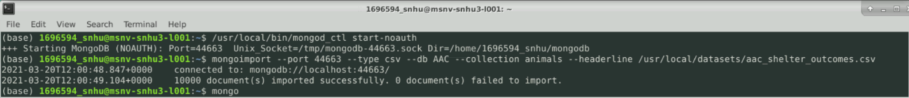

**2: Create simple index**

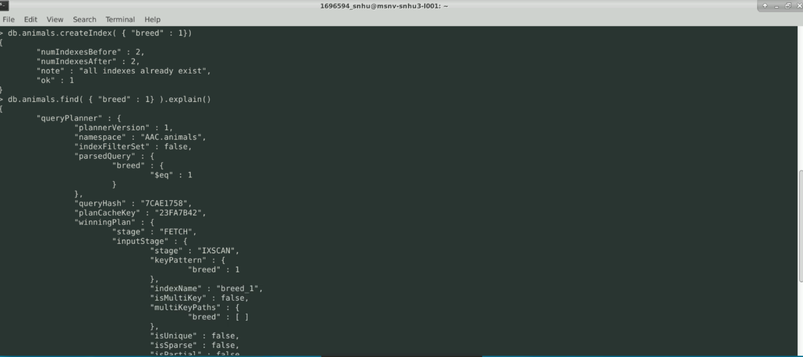

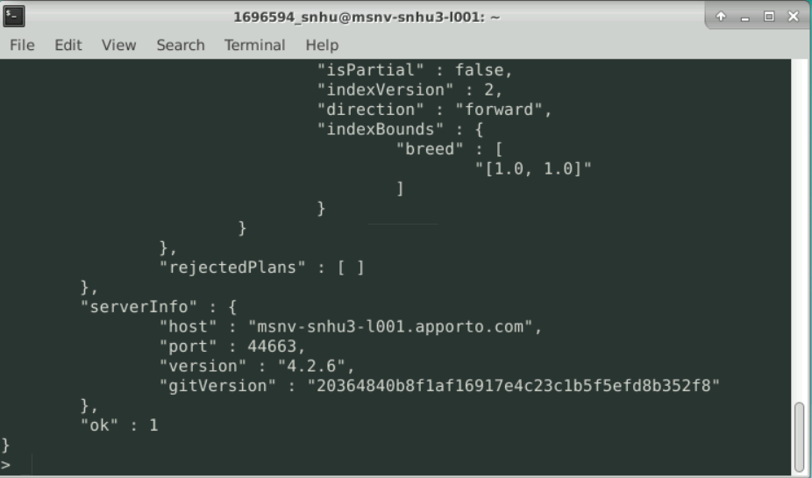

**3: Create Compound Index**

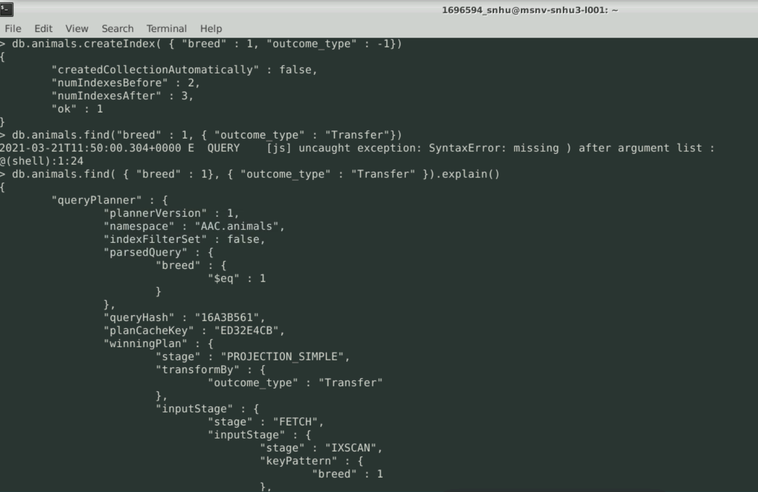

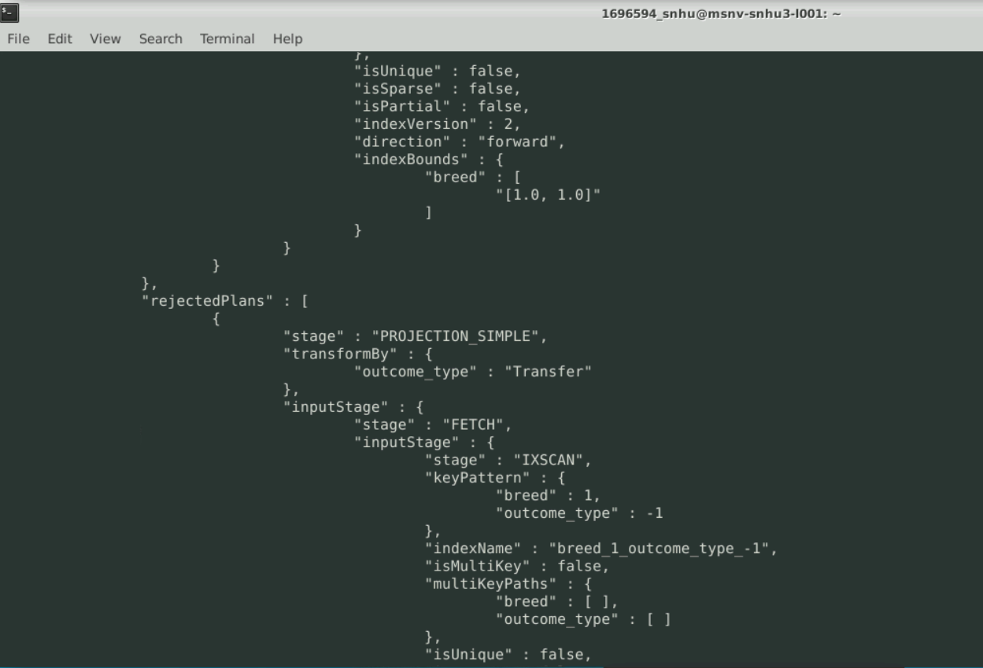

**II: User Authentication**

**1: Create an administrator account**

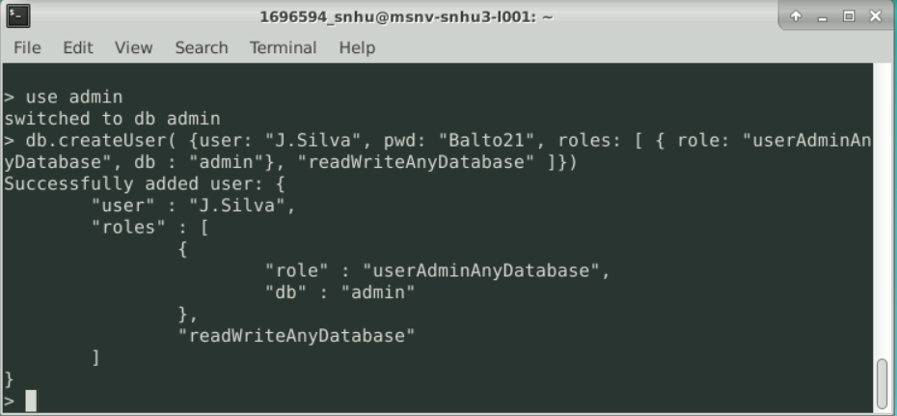

**2: Enable user authentication for the database**

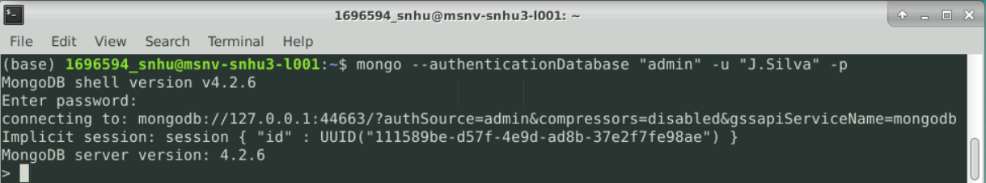

**3: Create a new user account called “aacuser”**

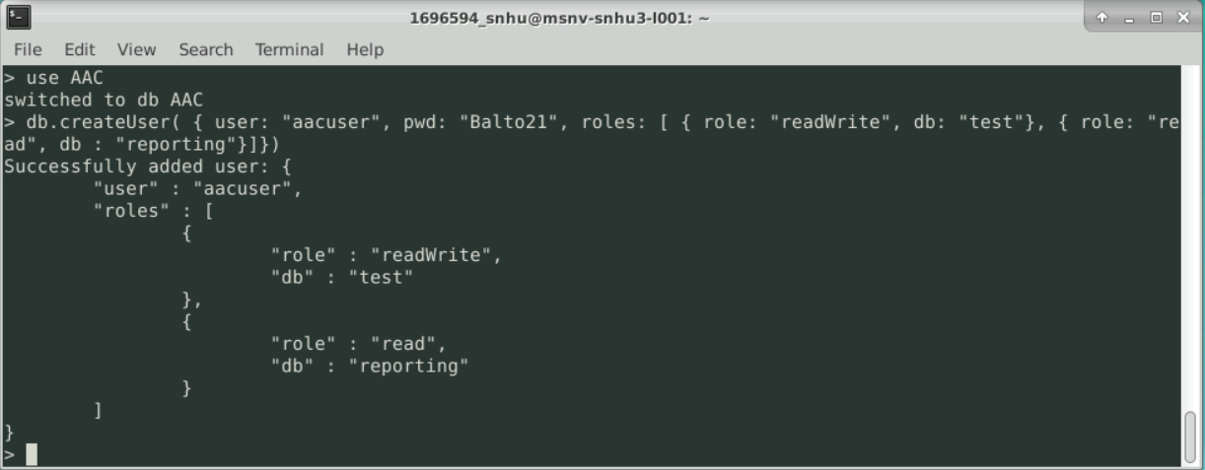

**4: Login process**

